Virginia Department of Education
Office of ESEA Programs

Frequently Asked Questions (FAQs) have been developed to assist school divisions and grantees during the COVID-19 pandemic. Below are FAQs from the VDOE COVID-19 website as well as 21st CCLC-specific questions that may be helpful to grantees.

Frequently Asked Questions – Updated March 25, 2020

- If we use federal funds to pay an employee and they are not working, but continue to be paid, can we claim this as a reimbursement?
Divisions should apply their employee compensation policies and procedures consistently for federally funded and non-federally funded employees. To the extent practicable, employees paid with federal funds should continue to work remotely on allowable grant activities or should be paid under the division’s established paid leave policy. If staff are not working during an emergency closure and non-federal funds are used to pay non-federally funded staff, federal funds may be used to pay federally-funded staff in the same manner.
- What are the suggestions for hourly employees/payroll?
In the event of a division closure, divisions may permit such employees to continue working remotely if in compliance with all laws and regulations. Otherwise, authorizing additional paid leave types for non-exempt employees during the state of emergency should be considered. VDOE recommends that local education agencies (LEAs) make employment and compensation related decisions in close consultation with their attorneys.
- What about part-time federally funded employees?
In the event of a division closure, permit such employees to continue working remotely if in compliance with all laws and regulations. Otherwise, authorize additional paid leave types for non-exempt employees during the state of emergency (also see Question #19).

- Please share guidance related to online or distance learning during an extended school closure.
The impact to students during an extended school closure can be significant. The learning time and support students receive at school are not easily supplemented or replaced. Understanding the desire and responsibility of parents and educators alike to provide continuity for every student in their thinking and learning, many school divisions are assessing the feasibility of providing online learning in the event of extended school closures. In looking at this option, it is important to consider the practical steps necessary to appropriately serve every student equitably and the extent to which a traditional school environment can be quickly replicated online. It is not a simple task, nor is it one that should be attempted without serious consideration of equity and access. Schools should thoughtfully evaluate their approach, understand their legal obligations, and maintain the standards for delivery of instruction and student supports. Services, programs and activities online must be accessible to persons, including individuals with disabilities unless equally effective alternative access is provided in another manner (U. S. Department of Education, Office for Civil Rights, 2020). Divisions may have the capacity to explore expanding or offering online learning. Divisions should apply an equity lens and consider the impacts on underserved groups, including students of color, students with disabilities, emerging bilingual students, students experiencing poverty and homelessness, and students who belong to other protected classes. Consider whether the model will improve or worsen disparities between populations. Consider barriers to equitable implementation and unintended consequences. Shifting from a “brick and mortar” school environment to online learning that meets the regulations of holding “school” is a complex task that requires thoughtful planning, serious consideration of practicality, and assessment of risk. This assessment of risk should consider the impact of compensatory education and exposure for local school divisions to dispute resolution. Additional guidance is also available from the U. S. Department of Education (USED) including a short webinar on online education and website accessibility and a fact sheet (PDF) on addressing the risk of COVID-19 in schools while protecting the civil rights of students.

- Will OMEGA reimbursement continue to be approved?
Yes.
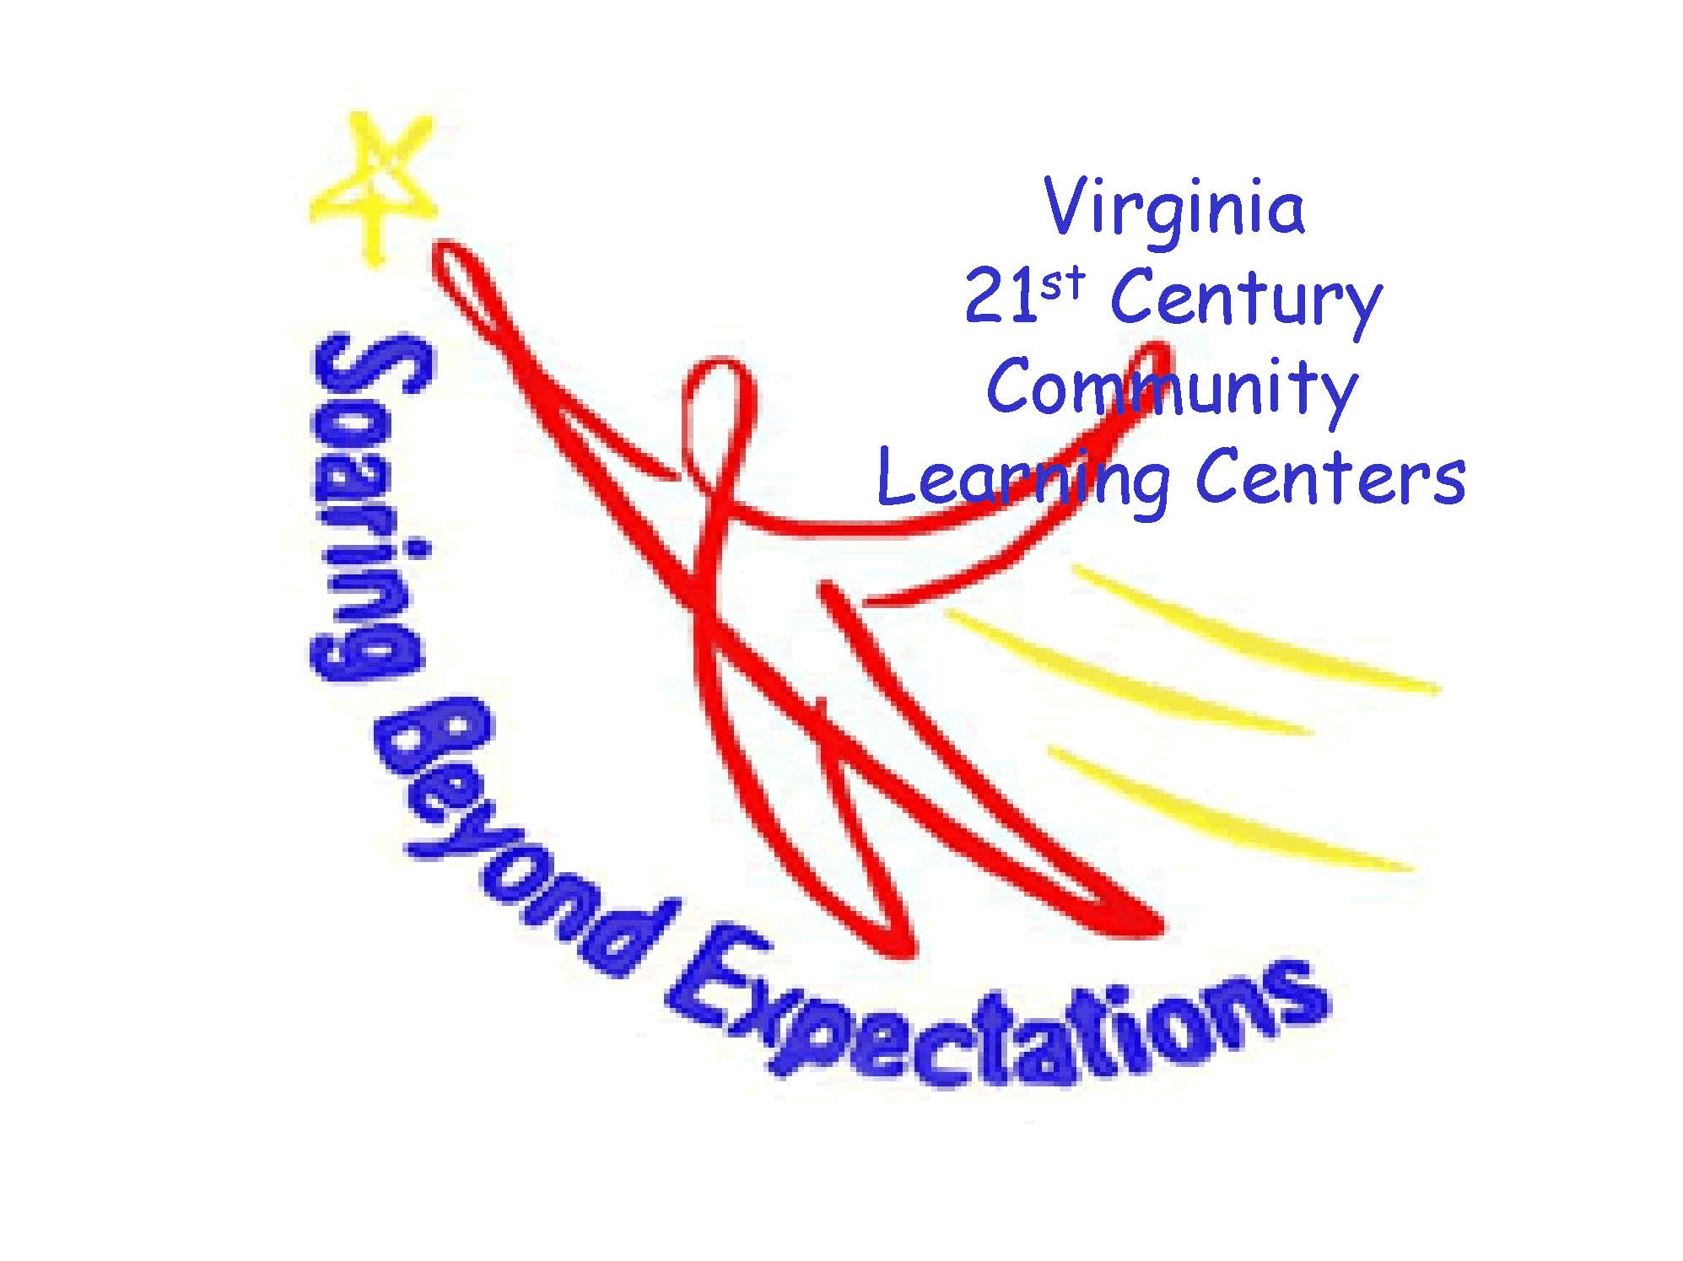
21st CCLC-Specific Frequently Asked Questions

- How will next year’s funding be affected if grantees are unable to meet student or parent program hours?
Based on this year’s circumstances, the requirement to meet student and parent hours will be waived.

- How did we calculate Average Weekly Attendance (AWA)?
Calculate AWA using the regular school year weeks through March 1, 2020, as stated in the continuation application.

- How will next year’s funding be affected if grantees don’t meet AWA?
The AWA calculation is based on regular school year weeks through March 1, 2020. As stated in the Administrative Handbook, failure to serve the AWA of students based on the numbers reported in the continuation application may result in a proportionate reduction in the subsequent years’ grant awards.

- Will my monitoring still take place?
Yes, on a modified timeline. Programs that were scheduled to be monitored in spring 2020 that did not receive a monitoring visit will be monitored in September-October 2020.

- My monitoring was completed. What can I expect?
For programs that had a complete monitoring visit, the Superintendent/Chief Executive Officer will receive a letter with the program’s monitoring results. Programs with findings will complete a Corrective Action Plan (CAP). Information regarding CAPs will be provided with the monitoring letter.

- How will program reporting be affected?
Grantees will be required to complete all data reports with the exception of the Student Survey. The data collected from grantee reporting is required for the State Evaluation.

- Can funds be used to order program supplies for the summer and next year?
Yes. Programs may continue to expend funds as needed to effectively operate their program and to prepare for summer school and the 2020-2021 regular school program (if eligible for continuation- refer to question #14).

- How will my summer program be affected?
Programs should seek guidance from the school division regarding summer school scheduling and building availability. If the school division permits summer school, proceed as planned. An amendment must be submitted to your assigned 21st CCLC specialist for any changes to the approved summer school plans.

- Can my summer school be extended?
Yes, but an amendment must be submitted to your assigned 21st CCLC specialist. Refer to question #8.

- Has the due date for continuation applications been extended?
Yes, the new due date for renewability applications (Cohort 15R only) and continuation application is Friday, April 24, 2020.

- Has the due date for the 2020 2021- RFP completion been extended?
Yes, the new deadline is Friday, May 1, 2020.

- Will there be an extension of 2018-2019 grant funds?
We anticipate that USED will release information on how states can request or will receive flexibility from certain ESEA requirements impacted by the pandemic. Areas of ESEA flexibility may include:
- Extending the period of performance for FY18 grants
- Using federal funds to cover nonrefundable fees and costs for federally funded events and activities that were canceled due to COVID-19

- How will 2019-2020 grant funds be affected?
USED has not released any information about flexibility for FY19 grants.

- What will happen to Year 3 programs’ 2019-2020 funding?
Year 3 programs that submit an application into the 2020-2021 competition and are not awarded funding will be allowed to run a Year 4 program with the remaining 2019-2020 funds. Year 4 programs may only expend funds on services for students and parents and day-to-day materials and supplies. Field trips and equipment purchases for Year 4 programs are unallowable. Final reimbursement must be submitted by June 1, 2021.

- If I plan to provide online or virtual academic, homework, or enrichments sessions, what must I provide to VDOE?
Programs that plan to continue to serve students in a virtual or online format must submit an amendment that describes the program, including:
- A description of the services (hours and days of service, how attendance will be taken, types of programming offered);
- A budget; and
- How the program will ensure access to all currently enrolled 21st CCLC students

- The virtual or online programming must take place outside the regular school day in areas where the school division provides school day services to students. Academic programming must be offered.

- What is allowable work for my staff?
Allowable work includes:
- Online programming;
- Virtual staff meetings and professional development;
- Curriculum and lesson plan design and development;
- Program planning;
- Providing student or parent social-emotional and well-being supports;
- Family education and engagement, such as information on resources to access during extended school closure;
- Gathering and disseminating materials and information; and
- Any other reasonable and necessary role that contributes to the grant during school closure.

- May I use 21st CCLC funds to feed students?
No. 21st CCLC funds may not be used for this purpose.

