NEW INSIGHTS MENTORING PROGRAM

Memorandum of Understanding

This Memorandum of Understanding (MOU) made this 7th day of January 2003 as managed by the New Insights Mentoring Program (NIMP). This MOU establishes that NIMP, Winwood Heights Middle School (WHMS), Winwood Heights High School (WHHS), and Winwood Heights Recreation Center (WHRC) agree to the following terms and conditions as partners in the New Insights Mentoring Program:

NIMP will:
- Identify, solicit, and recruit volunteer mentor applicants
- Manage programmatic activities including but not limited to development of policies and procedures, fund development, and case management
- Oversee all operational activities including screening, training, matching, support and supervision, recognition, and closure procedures
- Coordinate one-to-one mentor and mentee matching to meet the goal of 25 new matches per year
- Manage all fiscal requirements including fund development, budget management, and fiscal planning
- Provide evaluation summaries of the project to all partners

WHMS will:
- Provide on-site coordination, an adequate project site, office space, and facility amenities
- Identify appropriate WHMS students for referral
- Advise on the academic needs of participating youth
- Assist in providing program evaluation data for participating students including grades, attendance records, discipline records, and counselor and teacher reports
- Provide a contact person
- Cooperate to the fullest extent possible with NIMP Coordinator

WHHS will:
- Provide on-site coordination, an adequate project site, office space, and facility amenities
- Identify appropriate WHHS students for referral
- Advise on the academic needs of participating youth
- Assist in providing program evaluation data for participating students including grades, attendance records, discipline records, and counselor and teacher reports
- Provide a contact person
- Cooperate to the fullest extent possible with NIMP Coordinator

Sample Partnership Agreements
(For use when partnering with an outside agency for recruitment or facilitation of program)

Sample MOU Template
WHRC will:
- Serve as the primary agency for group recreational activities and games
- Provide training programs in youth development, leadership, and relationship building to mentors and program staff
- Provide a contact person
- Cooperate to the fullest extent possible with NIMP Coordinator

NIMP, WHMS, WHHS, and WHRC will hold all information confidential regarding participants and release such information only with signed parental consent or in cooperation with law enforcement investigations in compliance with local and state laws and statutes.

In witness whereof, the parties hereto have caused this MOU to be executed as of the day and year listed below.

New Insights Mentoring Program:

_________________________ __________________________ ____________
Name Title Date

Winwood Heights Middle School:

_________________________ __________________________ ____________
Name Title Date

Winwood Heights High School:

_________________________ __________________________ ____________
Name Title Date

Winwood Heights Recreation Center:

_________________________ __________________________ ____________
Name Title Date

Sample Outline of Various Partner Responsibilities

LEADERSHIP STRUCTURE

KEY STAFF CONTACTS (PRINCIPAL/COUNSELOR)
One key contact at each school served.
- Responsibilities
  - Accepts and oversees the mentoring program in the school
  - Matches new mentors with teachers who have requested a mentor based on schedule and interests
  - Matches and oversees new mentors with students who have been referred to receive out-of-classroom assistance. Sends home Parent/Guardian Consent Form to gain consent from parent for child to work with volunteer mentor. Mentee materials may also include Mentee Application, Participant Agreement, and Mentee Interest Survey
  - Provide volunteer FISH mentors with volunteer orientation and overview of school policies (signing in, emergencies, process to follow in case of absence)
  - At the close of the school year, distribute closure materials and activities to teachers
  - Available for problem resolution with mentor, teacher, mentee when needed

- Expected Commitment
  - Reviews and signs partnership agreement
  - Attend one-hour orientation session detailing program
  - Review and sign policies and procedures for the program
  - Maintain regular contact with program staff
TEACHERS

All teachers that receive a requested mentor/tutor as a resource.

- Responsibilities
  - Identifies student(s) to receive assistance from mentor
  - Determine suitable match based on the following criteria:
    - Common interests
    - Compatible personalities
    - Similar gender, when possible
  - Guides the activities of the mentor. Is prepared for mentor every week.
  - Supports the mentor. May inquire:
    - Are they enjoying participating?
    - How do they feel it is going?
    - Are they having any difficulties?
    - Is the relationship developing as they would like?
    - If not, why do they think it is not?
    - Are there any concerns that should be addressed
  - As a part of match support, sometimes these questions are asked of the mentee as well.
  - Makes time to address questions/concerns that the mentor may have (may be submitted with a paper form at the end of each session or each month)
  - Supervise closure activities provided by program
- Expected Commitment
  - Attend one-hour orientation session detailing the roles and expectations of program mentors
  - Review and sign policies and procedures for participation in program
  - Maintain regular contact with program staff

PROGRAM STAFF

- Provides overarching mentor support
  - Are they enjoying participating?
  - How do they feel it is going?
  - Are they having any difficulties?
  - Is the relationship developing as they would like?
  - If not, why do they think it is not?
  - Are there any concerns that should be addressed by program staff?
- Make contact with mentors and teachers after first two weeks of the match
- Create and oversee implementation of an ongoing mentor recruitment plan, including development of an annual recruitment and quarterly activity plans, development and distribution of program marketing materials, presentations to targeted organizations, and ensuring a presence at key community events.
- Perform participant screening and training. Oversee participant matching, support, supervision and closure activities.
- Develop and manage relationships with schools
- Establish regular communications structure with primary school staff and teachers to share feedback, concerns, and needed resources. Send end-of-year surveys to all school staff contacts, teachers, and mentors
- Distribute program resources for school staff contact and teacher use.
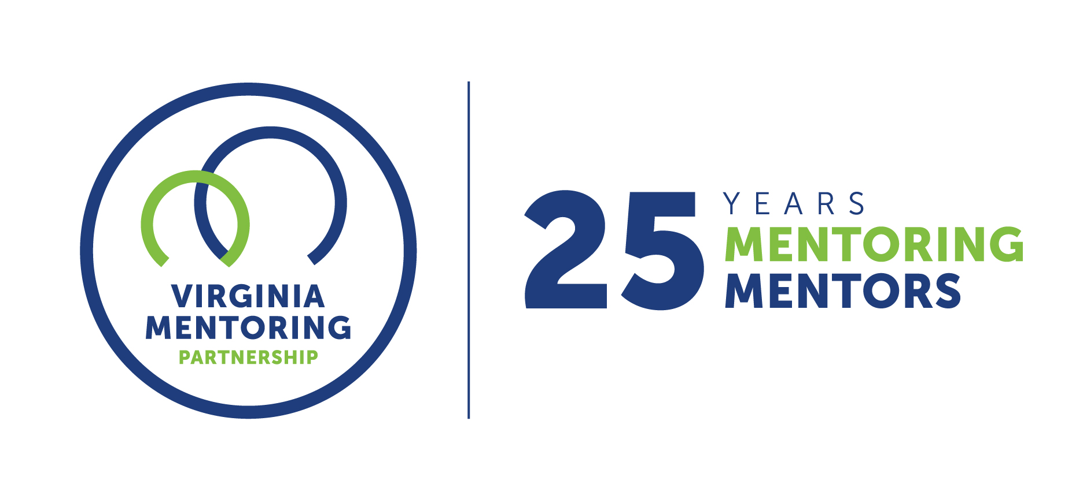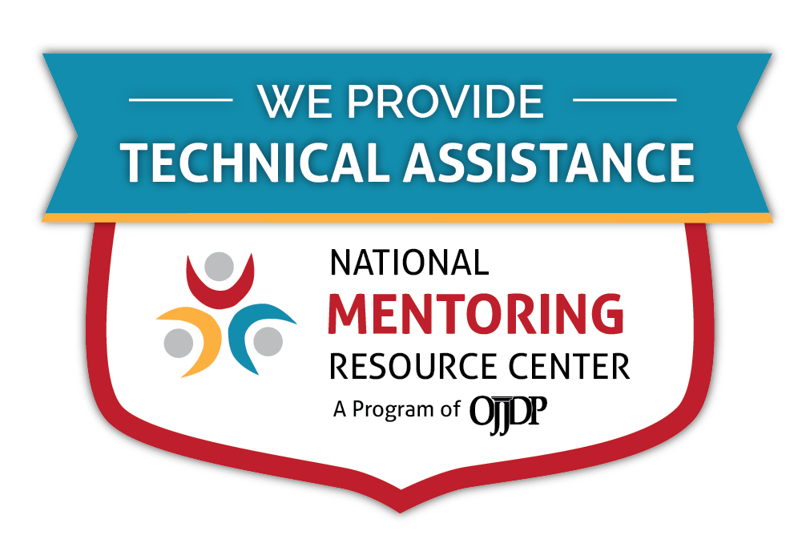
For further guidance on implementing these resources, contact Virginia Mentoring Partnership. Virginia Mentoring Partnership is a statewide 501c3 anchor organization committed to supporting the quality, sustainability, and capacity of mentoring programs. Services available to programs include training, technical assistance consulting, and quality assurance.
As an affiliate Mentoring Partnership of MENTOR: The National Mentoring Partnership (MENTOR), Virginia Mentoring Partnership is proud to be a technical assistance provider for The National Mentoring Resource Center (NMRC), a project of The Office of Juvenile Justice and Delinquency Prevention and MENTOR. This youth mentoring resource is no-cost for programs and aims to strengthen mentoring quality and effectiveness. Through this free consulting time, VMP can provide guidance and resources for program staff on topics of their choice, ranging from basic program design to establishing a recruitment plan to developing outcome measurements. Connect with our Program Services staff today at www.vamentoring.org, betsy@vamentoring.org.

