Sample Mentor Job Description
Updated January 31, 2003
The New Insights Mentoring Program of Winwood Heights helps to empower youth in our community to make positive life choices that enable them to maximize their potential. The mentoring program uses adult volunteers to commit to supporting, guiding, and being a friend to a young person for a period of at least one year. By becoming part of the social network of adults and community members who care about the youth, the mentor can help youth develop and reach positive academic, career, and personal goals.

Mentor Role
- Take the lead in supporting a young person through an ongoing, one-to-one relationship
- Serve as a positive role model and friend
- Build the relationship by planning and participating in activities together
- Strive for mutual respect
- Build self-esteem and motivation
- Help set goals and work toward accomplishing them
Time Commitment
- Make a one-year commitment
- Spend a minimum of eight hours per month one-to-one with a mentee
- Communicate with the mentee weekly
- Attend an initial two-hour training session and additional two-hour training sessions twice during each year of participation in the program
- Attend optional mentor/mentee group events, mentor support groups, and program recognition events

Participation Requirements
- Be at least 21 years old
- Reside in Winwood Heights metro area
- Be interested in working with young people
- Be willing to adhere to all program policies and procedures
- Be willing to complete the application and screening process
- Be dependable and consistent in meeting the time commitments
- Attend mentor training sessions as prescribed
- Be willing to communicate regularly with program staff, submit activity information, and take constructive feedback regarding mentoring activities
- Have access to an automobile, auto insurance, and a good driving record
- Have a clean criminal history
- No use of illicit drugs
- No use of alcohol or controlled substances in an inappropriate manner
- Not currently in treatment for substance abuse and have a non-addictive period of at least five years
- Not currently in treatment for a mental disorder or hospitalized for such in the past three years

Desirable Qualities
- Willing listener
- Encouraging and supportive
- Patient and flexible
- Tolerant and respectful of individual differences

Benefits
- Personal fulfillment through contribution to the community and individuals
- Satisfaction in helping someone mature, progress, and achieve goals
- Training sessions and group activities
- Participation in a mentor support group
- Mileage and expenses are tax deductible
- Personal ongoing support, supervision to help the match succeed
- Mentee/mentor group activities, complimentary tickets to community events, participant recognition events

Application and Screening Process
- Written application
- Driving record check
- Criminal history check: state, child abuse and neglect registry, sexual offender registry
- Personal interview
- Provide three personal references
- Attend two-hour mentor training

Annual Recruitment Plan
Final January 1, 2008

Recruitment Objective
Attract 25 new mentors matched with youth by December 31, 2008.

Target Audience
Men and women in Winwood Heights metro area with an emphasis on increasing the number of male and minority mentors.

Positioning Statement or Core Communication Message
To help a young person develop a positive vision for the future, be a mentor.

Promotional Materials
- New Insights Mentoring Program brochure (tri-fold)
- Informational flyers
- Newsletter
- Press releases
- Generic news article (for newsletters, papers, and local magazines)
- Program presentation with overheads, notes, and handouts
- Web site development

Promotional Activities
- Place brochure and flyer throughout the community (continuous)
- Display tables at local events (as available)
- Distribute newsletter (quarterly)
- Distribute press release and PSA to local media (quarterly)
- Make personal contact with key media and organization leaders (2–3 per month)
- Present to community organizations (1–2 times per month)
- Garner inquiries from Web site (online interest form) and e-mail (continuous)

Target Organizations
- Local Colleges: Winwood Community College
- Local Businesses: Winwood Community Hospital, TechRider Electronics
- Professional Associations: Winwood Chamber of Commerce, Black Business Alliance N/NE Business Assoc., African American Ministerial Alliance, Winwood Rotary
- Churches/Faith-Based Groups: Save Ministries, Winwood Baptist Church, Greater Winwood Christian Faith Tabernacle
- Governmental Agencies: Police and Fire Departments

Quarterly Recruitment Activity Plan
First Quarter, 2008

Activity | Date Complete | Person Responsible
Promotional Material Development:
Update Brochure – new copy, photos | 1/31/03 | Program Coord.
Press Release/PSA – New Board president announcement | 2/1/03 | Program Coord.
Web Site Update – Add page for Board w/pictures | 2/15/03 | Program Coord.
Write Newsletter – 2nd Quarter | 3/25/03 | Program Coord.
Promotional Activities:
Inquiry Responses – Web, phone, e-mail | Daily | Program Coord.
Mail Out First Quarter Newsletter | 1/1/03 | Office Manager
Distribute Brochures, Flyers | Weekly | Program Coord., Board Members, Other Staff
Mentor Orientation Session, 7–9 pm | 1/14/03 | Program Coord.
Display Table – Winwood Community College | 1/20/03 | Program Coord.
Contact Rotary – Request to speak at Q2 meeting | 1/31/03 | Program Coord.
Meeting/Presentation – Winwood Hospital | 2/5/03 | Board President, Executive Director
Mentor Orientation Session, 7–9 pm | 2/11/03 | Program Coord.
Chamber Luncheon Speech | 2/20/03 | Board Member, Program Coord.
Meeting/Presentation – Save Ministries | 3/4/03 | Executive Director,  Program Coord.
Mentor Orientation Session, 7–9 pm | 3/11/03 | Program Coord.
Board Meeting Presentation | 3/13/03 | Executive Director, Program Coord.
Radio Interview – KNEWS | 3/2/03 | Program Coord.

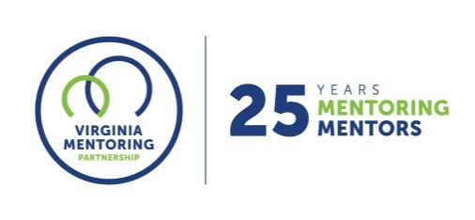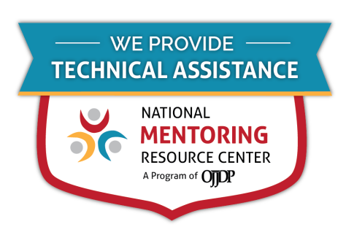
For further guidance on implementing these resources, contact Virginia Mentoring Partnership. Virginia Mentoring Partnership is a statewide 501c3 anchor organization committed to supporting the quality, sustainability, and capacity of mentoring programs. Services available to programs include training, technical assistance consulting, and quality assurance.
As an affiliate Mentoring Partnership of MENTOR: The National Mentoring Partnership (MENTOR), Virginia Mentoring Partnership is proud to be a technical assistance provider for The National Mentoring Resource Center (NMRC), a project of The Office of Juvenile Justice and Delinquency Prevention and MENTOR. This youth mentoring resource is no-cost for programs and aims to strengthen mentoring quality and effectiveness. Through this free consulting time, VMP can provide guidance and resources for program staff on topics of their choice, ranging from basic program design to establishing a recruitment plan to developing outcome measurements. Connect with our Program Services staff today at www.vamentoring.org, betsy@vamentoring.org.

