Program Implementation Timeline
(This timeline is designed to serve as a guide, as many mentoring programs take six to nine months to begin operating.)

Task | Description | Time Period
PLANNING: |  | Months 1 – 3
Pre-Planning | Conduct Needs Assessment. | Varies by Program
Pre-Program Development | Review the Elements of Effective Practice
Structure the Mentoring Program | Determine the purpose, type of youth/student needs, goals, mentoring model, and structure of the program as outlined in the Elements.
 | Assign/hire program coordinator.
 | Form an advisory committee.
 | Develop/select forms and determine budget.
MENTOR/MENTEE RECRUITMENT AND SELECTION: |  | Month 4
Mentor Recruitment | Develop criteria for mentee selection.
 | Identify potential sources for recruitment.
 | Develop public relations materials.
 | Make contacts and mail marketing/public relations information.
 | Follow up on all sources.
Mentee Recruitment | Develop criteria for mentee selection.
Mentor/Mentee Selection | Determine if prospective mentors/mentees meet criteria.
 | Select only those who fit the established criteria.
Document Data about Mentees | Choose data to document on the basis of the outcomes you wish to accomplish. Also, disseminate a pre-mentoring survey to mentees.
ORIENTATION AND TRAINING: |  | Months 5 – 6
Pre-Orientation and Training | Identify trainers.
 | Conduct staff training.
Mentor Orientation | Orient potential mentors to the program. Potential mentors complete application form and consent to a background check.
Mentee Orientation | Orient interested youth to the program Clearly communicate expectations. Potential mentees complete an application form. Parent permission is granted.
Mentor Training | Contact Virginia Mentoring Partnership for training opportunities.
Mentor Application Review, Screening and Selection | Review applications and complete screening and background checks.

Task | Description | Time Period
MATCHING:
Pre-Matching | Develop criteria for matching. | Prior to orientation
 | Match students and mentors on the basis of information from application (gender, interests, career interest, skills).
Kick-Off | Formal opening of the program that allows for the first mentor/mentee meeting and “getting to know you” activities. Parents may be invited. | Varies according to program
Mentor/Mentee Activities | Arrange for group activities on a regular basis. | Could be held monthly, but should be held at least quarterly
 | Assist mentors/mentees with activity ideas. | Regularly
ONGOING MAINTENANCE AND SUPPORT:
Feedback from Mentors and Mentees | Determine a mechanism for getting regular feedback from mentors and mentees. | Prior to mentor training
Additional Mentor Training and Support Sessions | Conduct regular mentor support meetings. | Varies according to the program
 | Monitor mentor/mentee relationships. | Monthly
RECOGNITION: | Celebrate and recognize the accomplishments of the program and mentor/mentee contributions. Invite stakeholders. | Annually at a minimum
EVALUATION:
Evaluate progress toward meeting goals and accomplishing objectives | Determine what outcomes to measure and evaluate. | During planning phase
 | Collect data on participants and mentors related to your outcomes. | Monthly
 | Measure outcomes and conduct evaluation. | Annually
 | Review program progress and refine as needed. | Annually
 | Reflect on and disseminate findings. | Annually

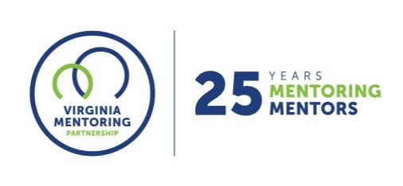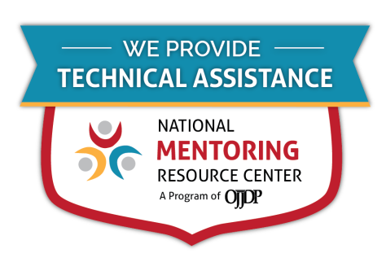
For further guidance on implementing these resources, contact Virginia Mentoring Partnership. Virginia Mentoring Partnership is a statewide 501c3 anchor organization committed to supporting the quality, sustainability, and capacity of mentoring programs. Services available to programs include training, technical assistance consulting, and quality assurance.
As an affiliate Mentoring Partnership of MENTOR: The National Mentoring Partnership (MENTOR), Virginia Mentoring Partnership is proud to be a technical assistance provider for The National Mentoring Resource Center (NMRC), a project of The Office of Juvenile Justice and Delinquency Prevention and MENTOR. This youth mentoring resource is no-cost for programs and aims to strengthen mentoring quality and effectiveness. Through this free consulting time, VMP can provide guidance and resources for program staff on topics of their choice, ranging from basic program design to establishing a recruitment plan to developing outcome measurements. Connect with our Program Services staff today at www.vamentoring.org, betsy@vamentoring.org.

Courtesy of and adapted from The Maryland Mentoring Partnership, Vision to Reality: Mentoring Program Development Guide, and Mentoring Partnership of Long Island, The ABC’s of Mentoring.

