Focus Group Resources
Staff Notes:
• Begin each Focus Group with a general welcome and introduction.
• Talk to the participants about what you are trying to accomplish and why they are there.
• Ask each participant to introduce him/herself, giving their name and telling the group one thing about themselves.
• Before the focus group starts, make sure you establish a way to take notes to collect the comments and suggestions (have a note taker, bullet chart, etc. Recording is probably not a good idea here).
• Consider handing participants a blank copy of the questions for them to think about or turn ideas into you later if they aren’t as comfortable sharing.
Introductions (5 min.): Sample: We would like your honest opinions on various questions—we are trying to help get some activities set up that you and your friends might be interested in and we really need your help figuring out what those might be. There are no right or wrong answers. Everyone’s opinion is important. Your answers will be confidential. We will be taking notes, so it’s important that only one person talk at a time. Please feel free to be informal; no need to raise your hand. Know that we will do our best to help put together real activities from these ideas and we hope we can count on your help in making at least some of them happen.
Questions: Staff Notes: When conducting the session spend 5 - 8 min. / question
1. What do you typically do after school [Typical answers are working, hanging out with friends, shopping, playing video games, watching reality TV, etc. From these general answers, it’s important to delve into what it is they like about it. The trick here is to try to think of positive ways they could do elements of what it is they like in mentoring sessions.]
2. If “working” comes up as an answer, ask what they do at their job and how often they do it? What do they like about their job? What don’t they like about it? Has it made them think about what kind of job they might like to have? If so, what?
3. What are your plans when you are done with high school? [If there’s a shoulder shrug, or a “Don’t Know,” try to delve deeper—what is it they’d like to do? They might be interested in going to college or a trade school, but they don’t know the path it would take to get there.]
4. Are there any activities you’d like to try if you had a chance?
5. If we were to offer activities, when would you like them to happen?
6. Would you be willing to help on a Leadership group to help plan these activities to make sure they meet your needs and interests?
7. Do you have any concerns or questions about this process or these activities?

Staff note: These are just sample questions—be sure you follow the conversation wherever it goes. Make sure one person doesn’t dominate the conversation—if you see that starting to happen, tell that person you appreciate their great input and let them know you’d love to talk to them more about their specific ideas after the session, but you’ve got to hear from the others while they are there—make sure to catch them before you break up the meeting to follow up or set an additional interview time. Be sure to thank the group for their great participation and leadership. Let them know you value their contributions and look forward to their help in making the activities happen. If they didn’t contribute much, give them your contact information and let them know they can email you their thoughts or set up another time to talk.

Mentee Focus Group Guide
- Before the focus group starts, make sure you establish a way to take notes to collect the comments and suggestions (have a note taker, bullet chart, etc…)
- Consider handing participants a blank copy of the questions for them to think about or turn ideas into you later if they aren’t as comfortable sharing.
- Begin each Focus Group with a general welcome and introduction.
- Ask each participant to introduce him/herself, giving their name and (telling the group one thing about themselves-if time permits).
- Talk to the participants about what you are trying to accomplish and why they are there [Insert Program Name] is working with a community volunteers who are interested in establishing a one on one mentoring program for [Insert Program Name].
- We would like your honest opinions on various questions—we are working on setting up a mentoring program for the [program target group, i.e.: middle school youth]. We need your input to help gage your interest level of having a mentoring program. There are no right or wrong answers. Everyone’s opinion is important. Your answers will be confidential. We will be taking notes, so it’s important that only one person talk at a time. Please feel free to be informal; no need to raise your hand. Know that we will do our best to help put together real activities from these ideas and we hope we can count on your help in making at least some of them happen.
Questions:
When you hear the word mentor what comes to mind for you?
Students Respond
Staff: Share the definition of a mentor: A mentor is a person or friend who guides a less experienced person by building trust and modeling positive behaviors.
The mentoring program we are working with would recruit adult mentors from our community. Mentors are people outside of your family

Now that we have a basic understanding of what a mentor is, what do you think mentoring would look like?
Students Respond
Staff: Share the definition of a mentoring. A structured and trusting relationship that brings young people together with caring individuals who offer guidance, support, and encouragement aimed at developing the competence and character of the mentee.

Have you ever had a mentor in your life? Do any of you currently have a mentor in your life?
Students Respond
Would you like to share who some of these people are or the program you participated in?
Students Respond

Now that we have a basic understanding of what a mentor is and mentoring would you be interested in having a mentor?
Students Respond
Staff: Great sounds like some of you would be interested and for those of you are not interested would you be willing to share why?
Do you think your peers would be interested in being part of a mentoring program?
Students Respond
Staff: The structure of the mentoring program would be one-on-one mentoring. This means you would be matched with a caring adult from the community and meet with them 1 hour week on a weekly basis.
How does this sound to you?

Could you see yourself making a 1 hour weekly commitment to the mentoring program?
Students Respond
What would you like to do during your mentoring sessions?
Students Respond
In what ways could a mentor support you?
Students Respond
What expectations would you have of a mentor?
Students Respond
Staff: Closing the session, thank the group for participating in the session and all their great feedback. And wrap up with this final question.
Would you like to share any other ideas, suggestions, thoughts, etc.?

Staff note: These are just sample questions—be sure you follow the conversation wherever it goes. Make sure one person doesn’t dominate the conversation—if you see that starting to happen, tell that person you appreciate their great input and let them know you’d love to talk to them more about their specific ideas after the session, but you’ve got to hear from the others while they are there—make sure to catch them before you break up the meeting to follow up or set an additional interview time. Thank the group for their great participation. Let them know you value their contributions.

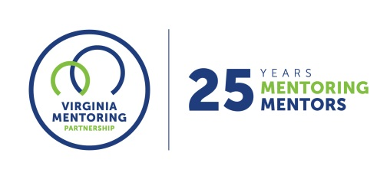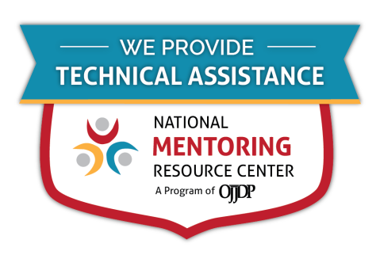
For further guidance on implementing these resources, contact Virginia Mentoring Partnership. Virginia Mentoring Partnership is a statewide 501c3 anchor organization committed to supporting the quality, sustainability, and capacity of mentoring programs. Services available to programs include training, technical assistance consulting, and quality assurance.
As an affiliate Mentoring Partnership of MENTOR: The National Mentoring Partnership (MENTOR), Virginia Mentoring Partnership is proud to be a technical assistance provider for The National Mentoring Resource Center (NMRC), a project of The Office of Juvenile Justice and Delinquency Prevention and MENTOR. This youth mentoring resource is no-cost for programs and aims to strengthen mentoring quality and effectiveness. Through this free consulting time, VMP can provide guidance and resources for program staff on topics of their choice, ranging from basic program design to establishing a recruitment plan to developing outcome measurements. Connect with our Program Services staff today at www.vamentoring.org, betsy@vamentoring.org.

