Mentor Match Worksheet

Mentee Name

Mentor Name

Date of Match

Program/School

Reason for Match | Match Criteria  Why you feel the match would be compatible and successful, considering the following match criteria:  - Common interests; background & skills of mentor and mentee  - Preferences of the mentor, mentee, and/or parent/guardian  - Similar gender/ethnicity  - Geographical proximity  - Similar personalities  - School/Parent Recommendation  Notes:

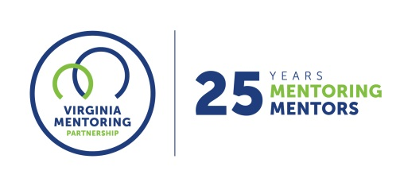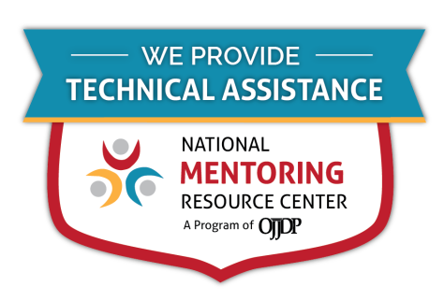
For further guidance on implementing these resources, contact Virginia Mentoring Partnership. Virginia Mentoring Partnership is a statewide 501c3 anchor organization committed to supporting the quality, sustainability, and capacity of mentoring programs. Services available to programs include training, technical assistance consulting, and quality assurance.
As an affiliate Mentoring Partnership of MENTOR: The National Mentoring Partnership (MENTOR), Virginia Mentoring Partnership is proud to be a technical assistance provider for The National Mentoring Resource Center (NMRC), a project of The Office of Juvenile Justice and Delinquency Prevention and MENTOR. This youth mentoring resource is no-cost for programs and aims to strengthen mentoring quality and effectiveness. Through this free consulting time, VMP can provide guidance and resources for program staff on topics of their choice, ranging from basic program design to establishing a recruitment plan to developing outcome measurements. Connect with our Program Services staff today at www.vamentoring.org, betsy@vamentoring.org.

