Relationship Development Checklist
Courtesy of the Maryland Mentoring Partnership’s
Vision to Reality Mentoring Program Development Guide

How Often Should My Program Check in with their Mentors?

Many programs have found that the following approach works well:

- Contact the mentor within the first two weeks of the match. Use this contact to make sure the pair is meeting, to find out what activities they have done together and to assess how the mentor feels about the match thus far.

- During the next few months, continue to check in with the mentor every two weeks. These ongoing contacts will help ensure that the mentor and youth meet regularly and are also important for uncovering any start-up problems that require program staff’s immediate assistance. (Many school-based mentoring programs keep track of how frequently each pair is meeting by having a logbook at the school where mentors sign in. However, it is still essential to have regular telephone or face-to-face contact to discuss the match.)

- For at least a year, continue to check in monthly with the mentor. The check-in discussion during this period should be focused on monitoring the quality of the mentoring relationship, assessing whether it is making progress toward its goals, learning whether the mentor or youth is losing interest in the match, and helping to address problems that may be arising between the pair. Your program should also make sure that mentors know how to contact staff, whenever necessary, for advice and support.

What Questions Should We Ask During the Check-Ins?

Possible questions for the mentor include:

- How is your match going? How do you feel about being a mentor?
- Do you and your mentee enjoy spending time together?
- What kinds of activities do you do when you are together?
- How do you decide what activities to do together? Do you and your mentee have trouble thinking up things to do together?
- Do you spend much time talking?
- How often do you see your mentee? How much time do you spend together at each meeting?
- Does your mentee keep appointments with you? Does he or she show up on time?
- When was your last meeting? What did you do together?
- Do you talk to your mentee on the telephone? How often? (for community-based programs)
- Do you need help with anything? Is there anything interfering with your match?
- How would you describe your mentee’s behavior? Does your mentee exhibit any behavior that you do not understand?
- How are things going with the parents and other family members? Is the parent of your mentee cooperative? (Or, for school-based programs: How are things going with the teacher?)
- Are you satisfied with how things are going?
- Is there any training you think would be helpful for you?
- Is there anything else we should be aware of?
- Is there anything we can do to help?

Questions to ask the youth include:

- Do you enjoy spending time with your mentor?
- What do you enjoy most about having a mentor? What do you enjoy least?
- When was the last time you met with your mentor? What did you do together?
- How often do you see your mentor? How long do your meetings last?
- Does your mentor keep appointments? Does he or she show up on time?
- Who decides what activities you are going to do together?
- Do you like talking to your mentor?
- Is there anything you would like to change about the visits?
- Is there anything you would like me to talk to your mentor about?

During the check-ins with parents/guardians, you can ask:

- Is your child happy with his or her mentor?
- Does your child look forward to seeing his or her mentor?
- Do they seem to enjoy being together?
- Is there anything you would like me to discuss with either your child or the mentor?
- How often does your child see his or her mentor? How long do the meetings last?
- Does the mentor usually keep appointments and show up on time?
- Is there anything that concerns you about the relationship?
- How do you think they feel about the mentor?
- What do you think of their weekly activities with the mentor?
- Would you like to see the activities change? How?
- How are they doing in school?
- Have you observed any positive or negative changes?
- Is there anything else we should be aware of?

Monthly Match Activity Report and Tracking

(Each match folder includes mentor and mentee applications including all contact information and consent forms)

Date Match Began Month/Year: ____________
Current Month/Year: _______________

Student Name: ______________________________
Best way to contact (phone, email, school): __________________________________

Mentor Name: ______________________________
Best way to contact (phone, email, work):____________________________________

Issues of a confidential nature should not be addressed on this form. Please contact (name of program coordinator) at (telephone number) for information and/or assistance.

Activity: | Week 1 | Week 2 | Week 3 | Week 4
Number of Phone Contacts
Number of E-mail/Fax Contacts
Number of In Person Contacts

- Total number of hours spent this month on mentoring activities: ____________________
(This should include the approximate amount of time spent during phone conversations,
e-mails and in person.)
- Please describe any activities the matches have been involved in this month. Check all that apply:
 school projects  tutoring  field trips  college preparation
 job shadow  school shadow  home visits  parent conferences
 social activities  goal setting  other: _________________________

Topics of conversation – generally what have the mentor and mentee been discussing?

3. Please check the appropriate box that best describes the mentee’s motivation in the following areas this month:
Activity: | Increased | No Change | Decreased | Don’t Know
Grades/school performance
School attendance
Time management skills
General attitude and outlook
Self-esteem
Confidence
Communication with adults
Willingness to accept responsibility

Monitor Tracking

This form tracks ongoing contact with program participants and flags areas where additional follow up is needed.

Mentor/Mentee Names: _____________________________________________________
Date Match Started:_________________________

Contact with the Mentor
Monitor/Support Activity | Date | Contact Made | Mode of Contact
Initial 2-week check in
(1st month) 2 week follow-up
(1st month) 2 week follow-up
(2nd month) 2 week follow-up
(2nd month) 2 week follow-up
(3rd month) Monthly check in
(4th month) Monthly check in
(5th month) Monthly check in
(6th month) Monthly check in
(7th month) Monthly check in
(8th month) Monthly check in
(9th month) Monthly check in
(10th month) Monthly check in
(11th month) Monthly check in
(12th month) Monthly check in

Contact made with the Mentee and Guardian
Monitor/Support Activity | Date | Contact Made | Mode of Contact
Initial 2-week check in
(1st month) 2 week follow-up
(1st month) 2 week follow-up
(2nd month) 2 week follow-up
(2nd month) 2 week follow-up
(3rd month) Monthly check in
(4th month) Monthly check in
(5th month) Monthly check in
(6th month) Monthly check in
(7th month) Monthly check in
(8th month) Monthly check in
(9th month) Monthly check in
(10th month) Monthly check in
(11th month) Monthly check in
(12th month) Monthly check in

Date:____________
Person Contacted:___________________
Staff:______________________________

For each check-in please answer the following questions:
(This is a guide and should not be used as a “script”)

- How often is the match meeting?

- What is the satisfaction level in the activities by program participants? What are the matches working on?

- How is communication going? Do the mentor and mentee find it easy to communicate with each other?

- Any grievance or positive developments to report about the match?

- Are there any “Red Flags” that have come up that need follow up?

Support Tracking

This form tracks support offered to program participants and tracks what resources have been used beyond

the initial orientation and training.

Mentor/Mentee Names: _____________________________________________________
Date Match Started:_________________________

Support for the Mentor:
What resources have been offered to the mentor?

Resource | Date | Follow up Needed
e.g. Handout on youth development from MMP | Jan 2008 | none
e.g. Match Activity Tickets to local Museum | Jan 2008 | none

Support for the Mentee and/or Family/Guardians:
What resources have been offered to the mentee and/or family/guardians?

Resource | Date | Follow up Needed
e.g. “Benefits of Mentoring” Fact Sheet | Jan 2008 | Check-in to see if they have any questions about the benefits.

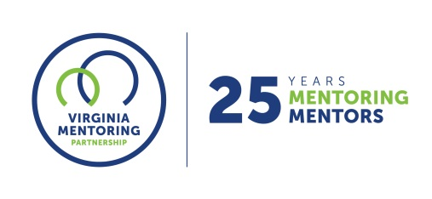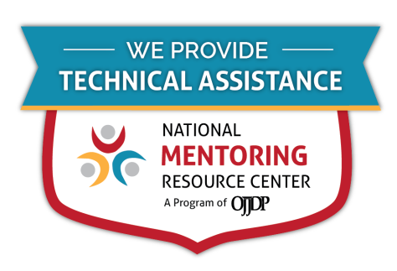
For further guidance on implementing these resources, contact Virginia Mentoring Partnership. Virginia Mentoring Partnership is a statewide 501c3 anchor organization committed to supporting the quality, sustainability, and capacity of mentoring programs. Services available to programs include training, technical assistance consulting, and quality assurance.
As an affiliate Mentoring Partnership of MENTOR: The National Mentoring Partnership (MENTOR), Virginia Mentoring Partnership is proud to be a technical assistance provider for The National Mentoring Resource Center (NMRC), a project of The Office of Juvenile Justice and Delinquency Prevention and MENTOR. This youth mentoring resource is no-cost for programs and aims to strengthen mentoring quality and effectiveness. Through this free consulting time, VMP can provide guidance and resources for program staff on topics of their choice, ranging from basic program design to establishing a recruitment plan to developing outcome measurements. Connect with our Program Services staff today at www.vamentoring.org, betsy@vamentoring.org.

