Mentor Exit Survey

Thank you for serving as a mentor in the_________(program name). Your efforts are greatly appreciated. We are always looking for ways to improve our program and appreciate your feedback. Please complete the following and return in the enclosed envelope.

Name:________________________________________ Date:________

Name of Mentee: ________________________________________________

Length of Match: ___years ____months

Check what best describes your relationship with your mentee. Then please explain your answers below:

Very close Close Not very close
Very successful Successful Not very successful

Why is your match ending?

Do you feel like you made a difference in your mentee’s life? Yes No
Please explain below:

Did you feel you received adequate support and supervision from program staff?

What aspects of the ___Mentoring Program did you like the best?

What aspects of the ___ Mentoring Program did you like the least?

What could we have done to make our program a better experience for you and/or your mentee?

Would you like to be re-matched? Yes No

Please provide any additional comments:

Mentee Exit Survey

Thank you for being a mentee in the____ Mentoring Program. We hope you enjoyed being a mentee. We are always looking for ways to improve our program and appreciate your feedback. Please complete the following and return in the enclosed envelope.

Name:________________________________________ Date:________

Name of Mentor: ________________________________________________

Length of Match: ___years ____months

Check what best describes your relationship with your mentor. Then please explain your answers below:

Very close Close Not very close
Very successful Successful Not very successful

Why is your match ending?

Do you feel like your mentor made a difference in your life? Yes No
Please explain below:

Did you feel you received adequate support and supervision from program staff?

What aspects of the ____ Mentoring Program did you like the best?

What aspects of the ______ Mentoring Program did you like the least?

What could we have done to make our program a better experience for you?

Would you like to be re-matched? Yes No

Please provide any additional comments:

Parent/Guardian Exit Survey

Thank you for letting your child participate in the _______Mentoring Program. We hope your child benefited from having a mentor. We are always looking for ways to improve our program and appreciate your feedback. Please complete the following and return in the enclosed envelope.

Name: ________________________________________ Date:________

Name of Child: ________________________________________________

Name of Mentor: ________________________________________________

Length of Match: ___years ____months

How would you describe your child’s relationship with his/her mentor? Please explain your answers below:

Very close Close Not very close
Very successful Successful Not very successful

Why did the match end?

Do you feel like your child’s mentor made a difference in his/her life? Yes No
Please explain below:

Did you feel you received adequate support and supervision from program staff?

What aspects of the ______ Mentoring Program did you like the best?

What aspects of the ________ Mentoring Program did you like the least?

What could we have done to make our program a better experience for you?

Would you allow your child to be re-matched? Yes No

Please provide any additional comments:

Closure Letter

Mentoring Program
Address

(Name of Mentor, Mentee, or Parent/Guardian)
(Address)

Dear (first name),

This letter is to inform you that the mentoring relationship managed by the __Mentoring Program has officially ended as of (match end date).

(Optional if applicable) We have made attempts to contact you via phone and e-mail to no avail and regret that we are unable to meet with you and go through a formal closure process.

As the match has formally ended, program name no longer assumes responsibility for monitoring and supervising the match and your file will be placed on an inactive status. Thus, any future contact between match partners is at the sole discretion of all parties involved (mentor, mentee, and parent/guardian). Any incidents occurring due to future contact among match participants is beyond the scope and responsibility of program name

Thank you for your involvement in our program. We appreciated your participation.

Please feel free to contact me if you have any questions.

Sincerely,

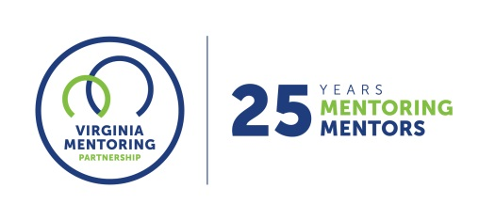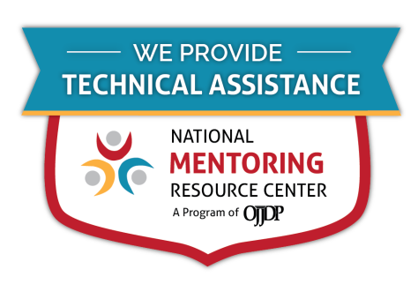
For further guidance on implementing these resources, contact Virginia Mentoring Partnership. Virginia Mentoring Partnership is a statewide 501c3 anchor organization committed to supporting the quality, sustainability, and capacity of mentoring programs. Services available to programs include training, technical assistance consulting, and quality assurance.
As an affiliate Mentoring Partnership of MENTOR: The National Mentoring Partnership (MENTOR), Virginia Mentoring Partnership is proud to be a technical assistance provider for The National Mentoring Resource Center (NMRC), a project of The Office of Juvenile Justice and Delinquency Prevention and MENTOR. This youth mentoring resource is no-cost for programs and aims to strengthen mentoring quality and effectiveness. Through this free consulting time, VMP can provide guidance and resources for program staff on topics of their choice, ranging from basic program design to establishing a recruitment plan to developing outcome measurements. Connect with our Program Services staff today at www.vamentoring.org, betsy@vamentoring.org.

