21st Century Community Learning Centers After-School Grant Program

Open House & Registration
at

Park View Middle School

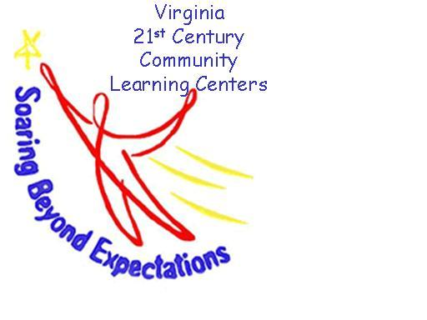

We are very happy to inform you that Park View Middle School has been awarded the 21st Century Community Learning Centers grant for the 2014-2015 school year.

This grant will allow us the opportunity to provide after-school remediation and enrichment programs three days a week for your child at no cost to you.

When: Thursday, September 11, 2014
Where: Park View Middle School – Cafeteria
Time: 5:30 p.m.

Look forward to seeing you!

